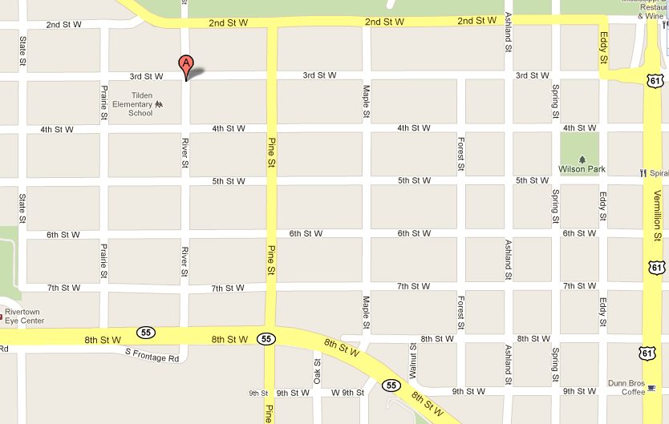
New Tilden Community Center Location: 310 River Street, Hastings, MN 55033

Tilden
Community
Center

